**Indoor Positioning & Tracking System**

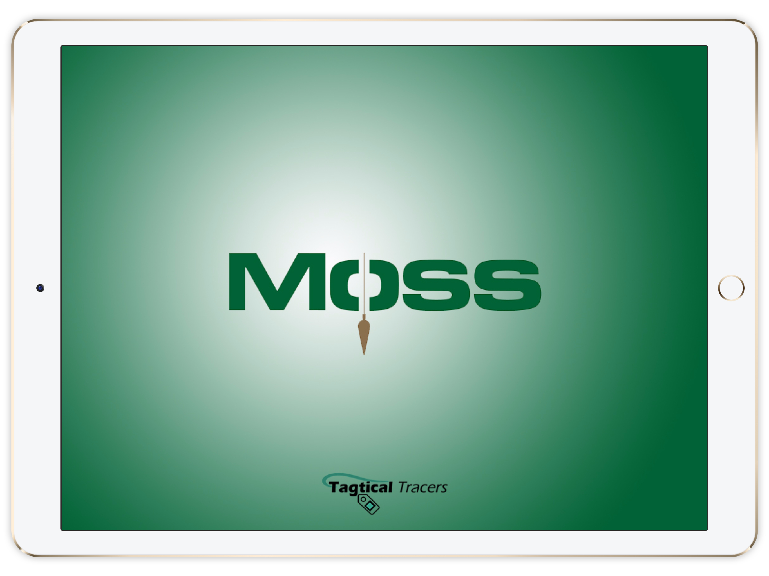

## Team Members:

* Robert Standifer (EE)

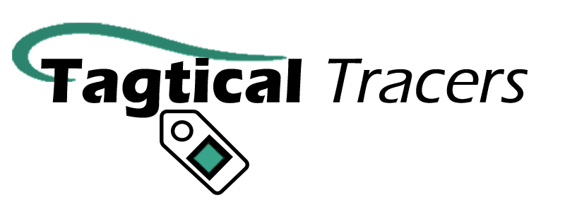

* Andres Gordo (EE)
* Kirsten Marie Palma (ME)
* Xiaoxi Zheng (DAS)
* Ricky Tran (CE)
* Phone Myint (EE)

Client Company: Moss Construction Management

## Coach: Professor Eisenstadt

­­

*This is an active ongoing project during Fall 2016 semester

# Software Component

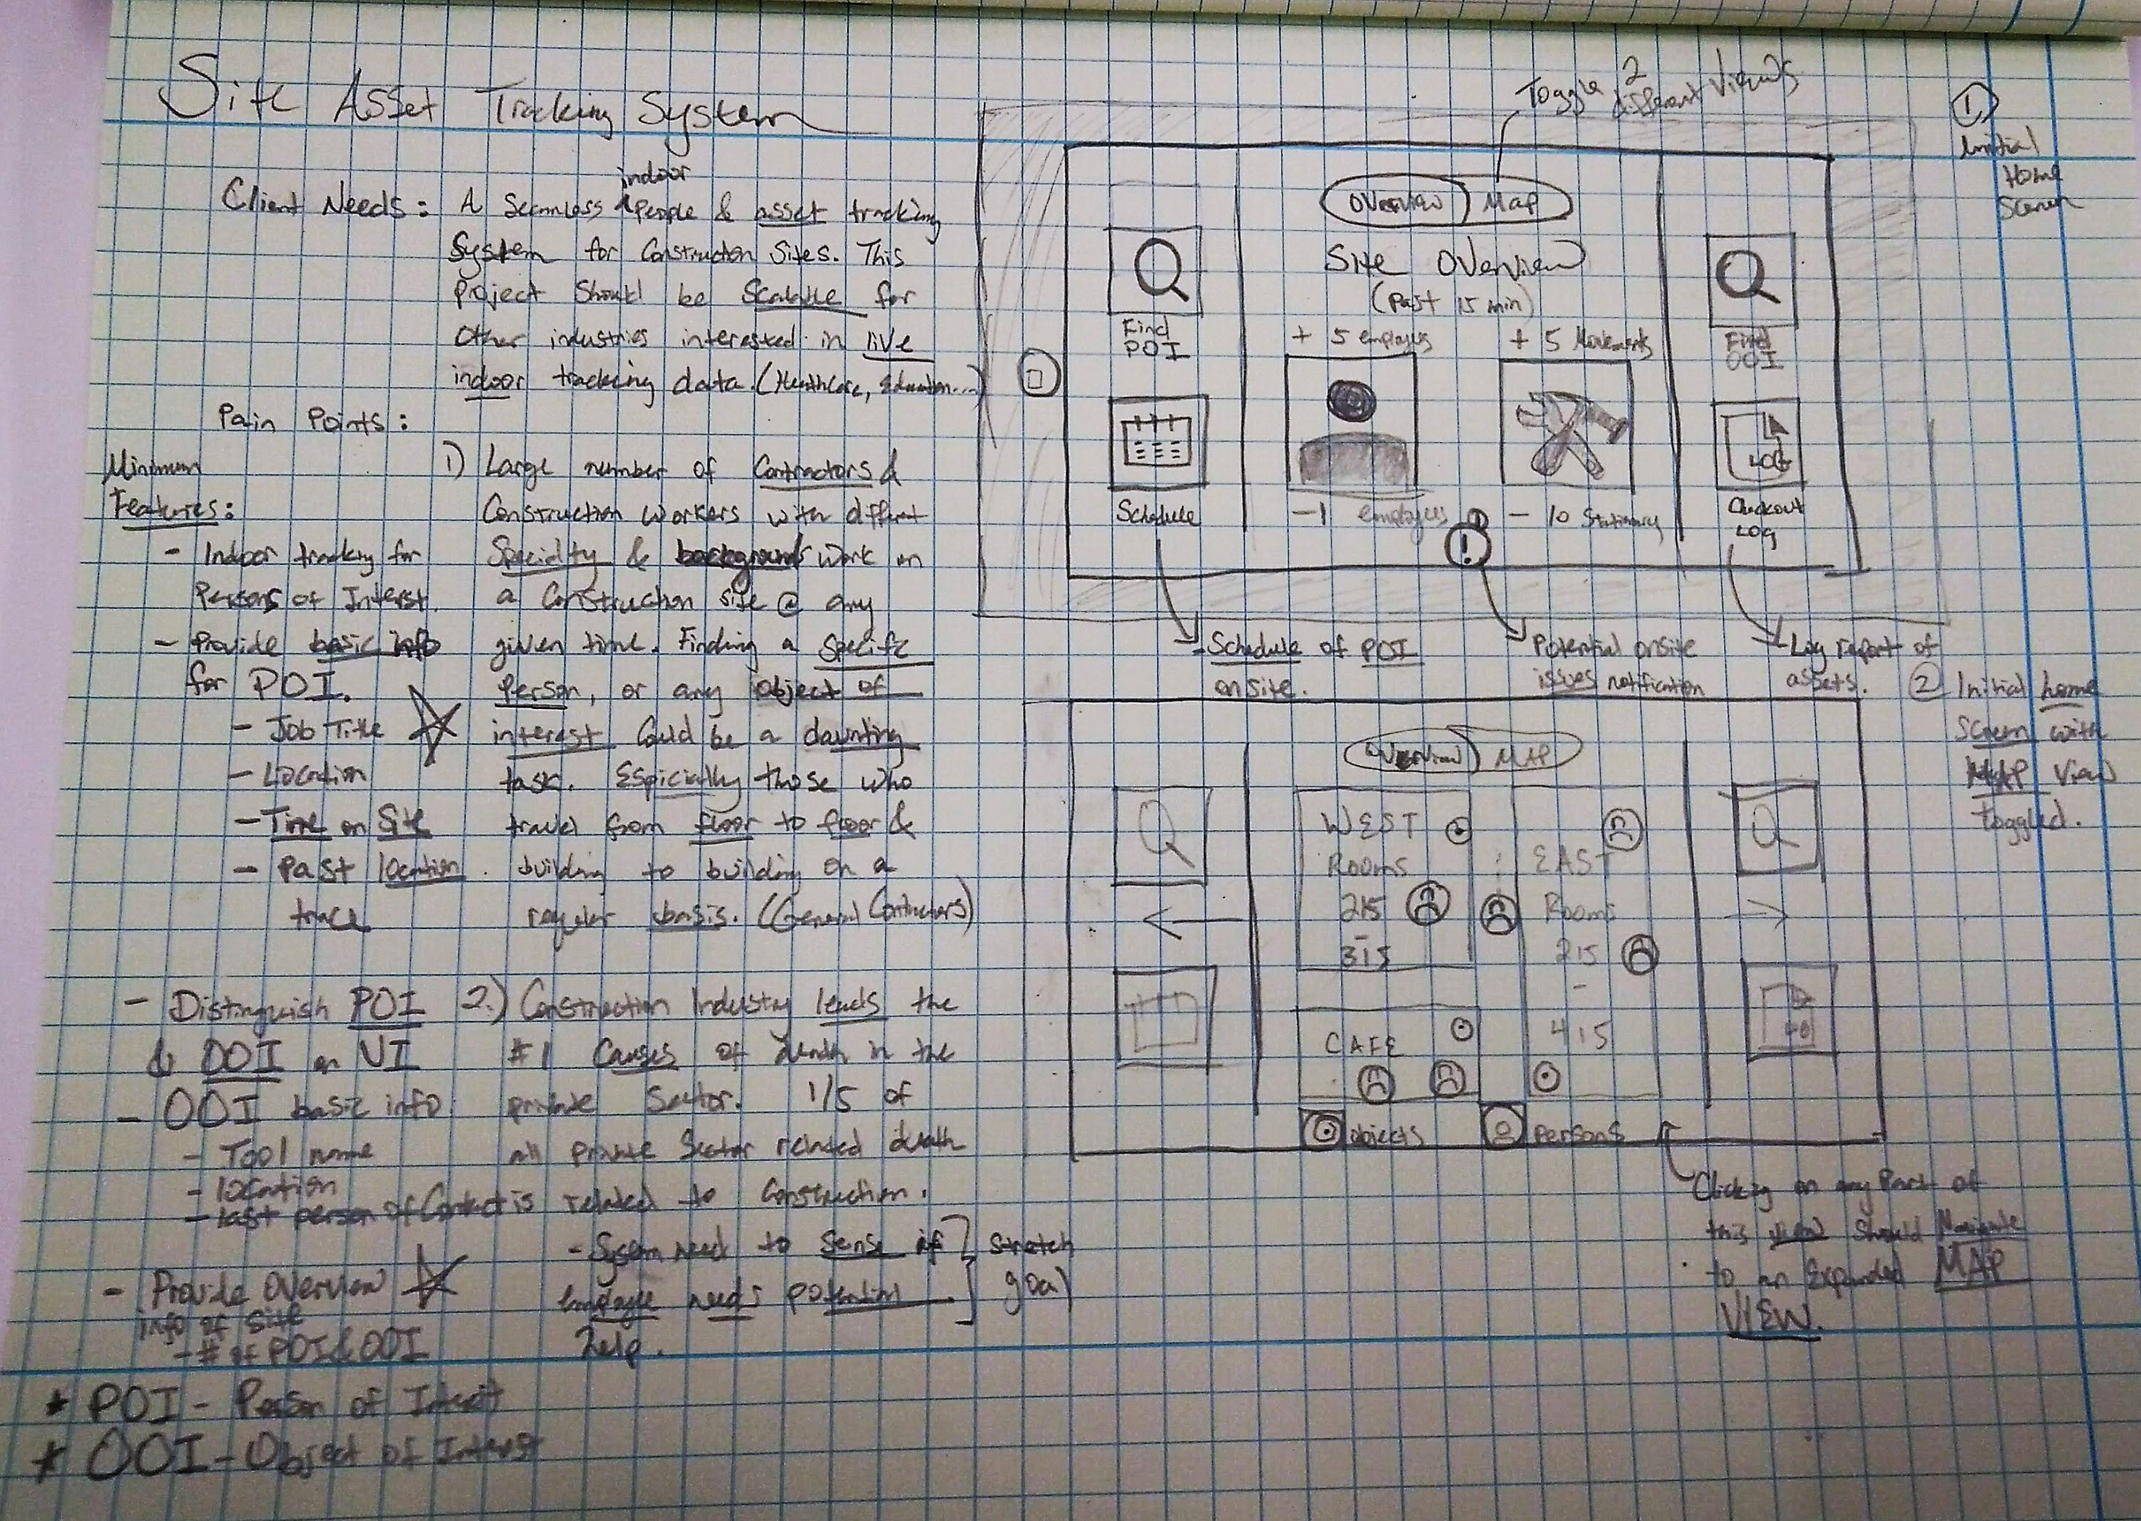

Summary:

We are creating a seamless IoT solution for indoor asset and people tracking. For this prototype, we are focusing on configuring the system to fit the construction industry specifically.

### Paint points:

* Large numbers of contractors & construction workers of different specialty and background work on a construction site at any given time. Finding a specific person with a particular knowledge on an active construction is a challenge.
* Construction industry leads the #1 cause of death in the private work sector. With indoor live data on active construction sites, this system will provide the extra layer of protection in cases of emergency.
* Different indoor assets gets displaced all the time by different active workers, this system will provide a layer of asset tracking at the end of the day.
* From the initial UI sketches, you will find us focusing on the two pain features. Finding what we define as Person of Interest (POI), and Object of interest (OOI). In the center of the interface, we define to give an overview of the site actively from our tracking devices.

# Sample UI:

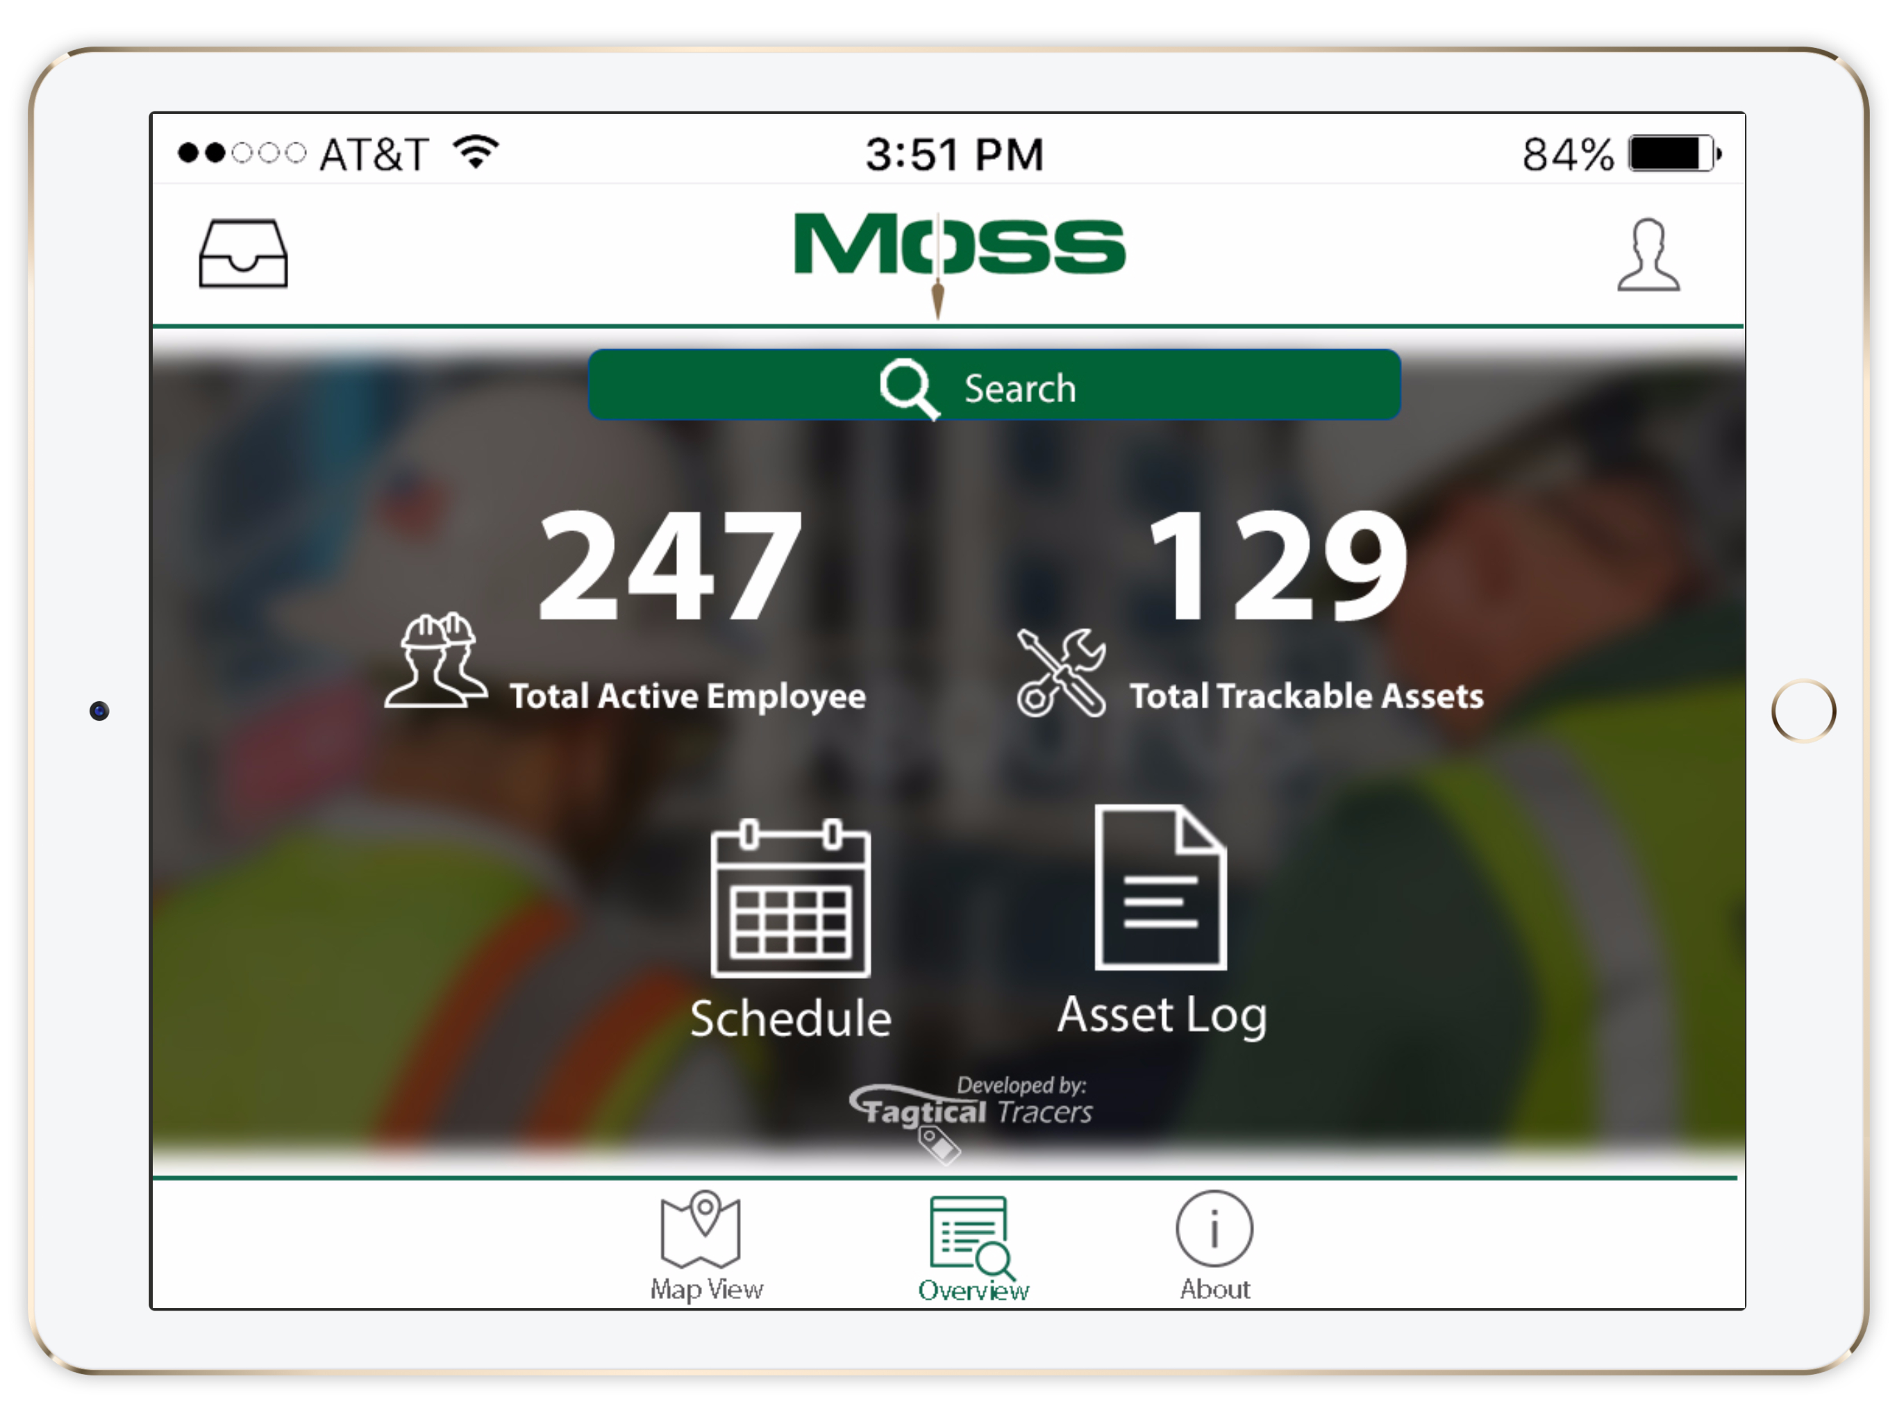

## System Overview Dashboard:

This screen provides an overview of across the entire company with all its ongoing projects. The numbers of active employees and trackable assets are being dynamically updated.

**Schedule**: A list of personnel whom is scheduled to be on an of the company site.

**Asset** **Log**: Provides a detail view of asset activity and their last known location.

## Map overview

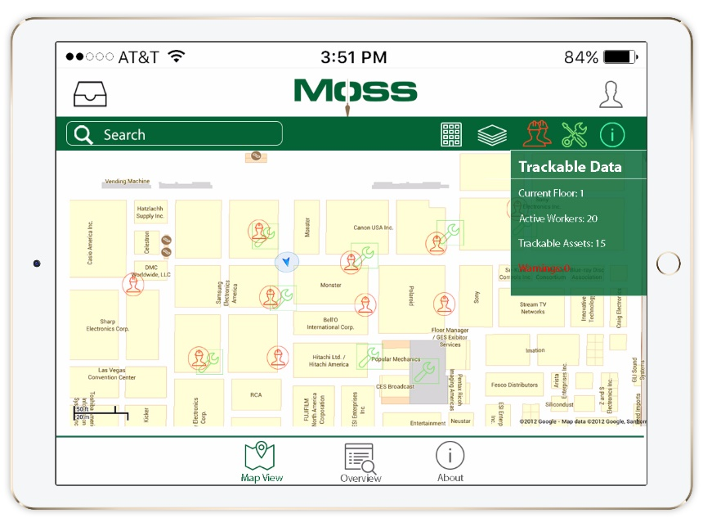**Inbox**: Live messaging capabilities between overhead management

**User Management:** For overall security of our system, users will be managed and gated to specific access.

**General Information toggle:**   
Toggling this icon will enable the user to view general live indoor location data. (Specific info of current floor, building, and the activities on the current floor)

**Asset location toggle:**Toggling this icon will enable the user to view live indoor location data of trackable assets.

**Employee location toggle:**   
Toggling this icon will enable the user to view live indoor location data of their employees.

**Building and floor selection:**

Toggling these 2 icons will enable users to select to view activities on a specified floor of a specified building.